Activity 1.3: Challenge exercise
Recreate this web page.
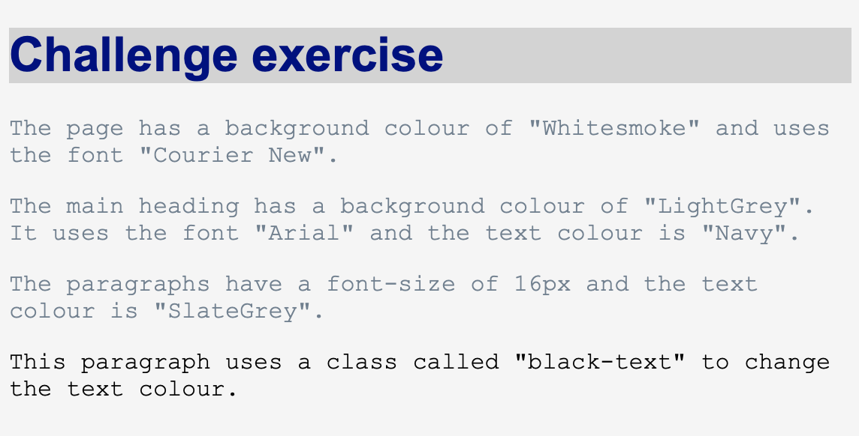
As well as editing 'lesson1_style.css' you will need to edit the text in 'lesson1_index.html.
Take a screenshot of the web page and insert it here:

Take a screenshot of your CSS code and insert it here:

